Homework 1

#1. [code]

import matplotlib.pylab as plt

import numpy as np

def straightLine(x):

return (30+(0.5\*x))

z = plt.linspace(0,10,10)

plt.plot(z,straightLine(z),"r")

plt.title("Straight Line Fxn")

plt.show()



def QuadraticFunction(x):

return ((x - 25)\*\*2 + 20)

r = plt.linspace(-50,100,100)

plt.plot(r,QuadraticFunction(r),"g")

plt.title("Quadratic Fxn")

plt.show()

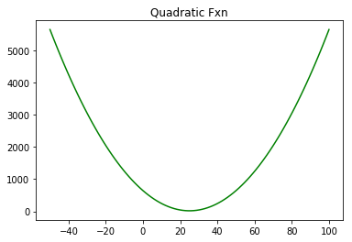

def LogFunction(y):

return (-(np.log(y)))

a= plt.linspace(-2,2)

b= plt.linspace(-2,2)

plt.plot(b,LogFunction(b),"r",label="-log(x)")

plt.plot(a,LogFunction(1-a), "b", label="-log(1-x)")

plt.title("Log Fxn")

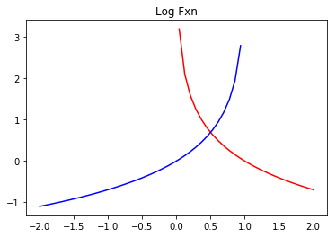

def sigmoid(x):

return (1 / (1 + np.exp(-x)))

y = plt.linspace(-10,10,100)

plt.plot(y, sigmoid(y), "b")

plt.title('Sigmoid Fxn')

plt.show()



#2. b)

#3. a) and d)

#4 The goal to create a personalized-medicine “painkiller” predictor. This categorical classification model would predict which painkiller(chemical composition) suits the best for the patient. In this example, we look at: Codeine, Hydrocodone, Oxycodone (OxyContin), Methadone, Hydromorphone, Fentanyl (Actiq, Duragesic)

Input: Patient’s medical history (past diseases and hospital visits). History of allergy to medication. Past prescriptions, and personal input to which painkiller worked the best.

Output: Best painkiller to take/recommended for future prescription, AND which ones to keep away.

Data preparation: training set can come from hospitals, pharmacies (ie. CVS), or Universities(school of medicines) OR personal entry data(phone apps).

Labels: age, height, race, location, and gender.

\*possible alternative: machine learning on ONLY over-the-counter Painkillers. What works best for what kind of patients.